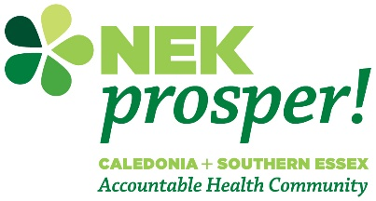
NEK Prosper! Healthy Cents Fund
LETTER OF INTENT

Deadline: April 19, 2023 at 11:59p.m.
Submit via e-mail to Diana Gibbs at d.gibbs@nvrh.org

Please provide the following information for your project.

Applicant Information:
Type of Applicant:
___Non-profit Organization ___Group/Association^ ___Individual* ___Other (please describe):
Name of Applicant (organization, group, individual):

^If you operate under the umbrella of a larger organization (for example, the Hub operates under Umbrella), please provide the name of the organization:

*If an individual, please provide the name of your fiscal sponsor organization:
Organization or Fiscal Sponsor Street Address (Street/Road, City, State, Zip Code):

Primary Contact Person Name (for project):

Primary Contact Person (for project) Email Address:

Primary Contact Person (for project) Preferred Phone Number:

Anticipated Amount Requested (No more than $25,000):

Project Information:

- Please select the Collaborative Action Network (CAN) outcome area that your project will advance, address, and/or otherwise positively impact. This project will impact the following CAN outcome areas (please select all that apply):
___ Mentally Healthy
___ Financially Secure
___ Physically Healthy
___ Well-Housed
___ Well-Nourished

- Priority will be given to projects identified and/or designed by those experiencing stigma, marginalization and avoidable systemic inequalities and who are typically left out of public health-oriented funding opportunities. Please identify the target population(s) for project:
___ Black, Indigenous, Persons of Color (BIPOC)
___ People living in rural areas/internet deserts
___ People experiencing homelessness or insecure housing
___ People with disabilities
___ People experiencing substance use disorders
___ People who are justice-involved
___ Refugees/Immigrants/multilingual communities
___ LGBTQIA+ people
___ People experiencing poverty
___ People experiencing mental illness
___ Other (please specify): __________________________________________________
__________________________________________________

- Have you or will you engage the target population(s) in the planning and implementation of your project?
___ Yes
___ No

If you responded yes, please describe your approach to engaging the target population(s)?

- Will this project be implemented in the NVRH service area?
___ Yes
___ No

What Vermont town(s) will be directly served by your project?

- Please provide a brief description of your project:

- Describe your team (the project champions and any community partners you are working with/intend to work with to achieve these results):

Thank you! You will be notified by e-mail on May 5th whether you are invited to submit a full proposal application or not. For questions regarding this NEK Prosper! Healthy Cents Fund opportunity or other support, please contact Diana Gibbs, VP of Marketing and Community Health Improvement, at d.gibbs@nvrh.org or call 802-748-7590.

